**Assignment-2**

**1.Red Hat Enterprise Linux**

**Step-1-**Enter server name

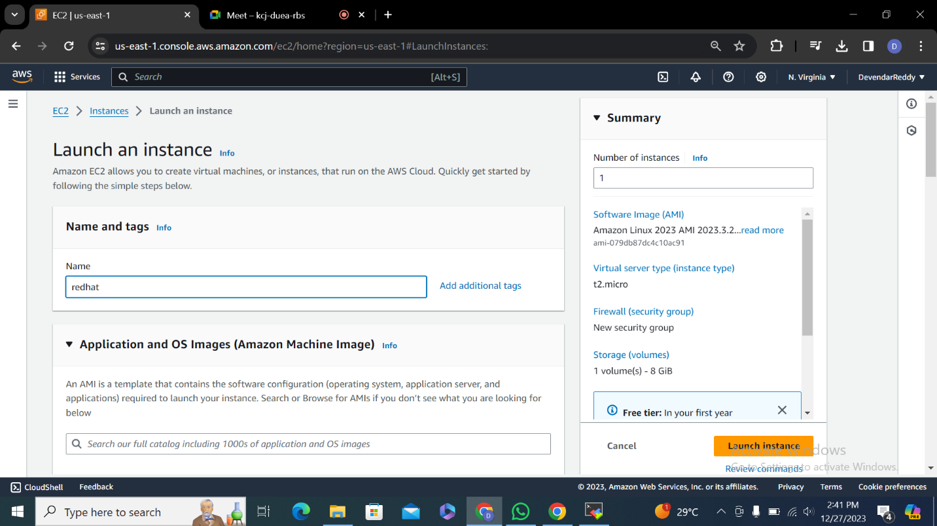

Step-2 select red hat os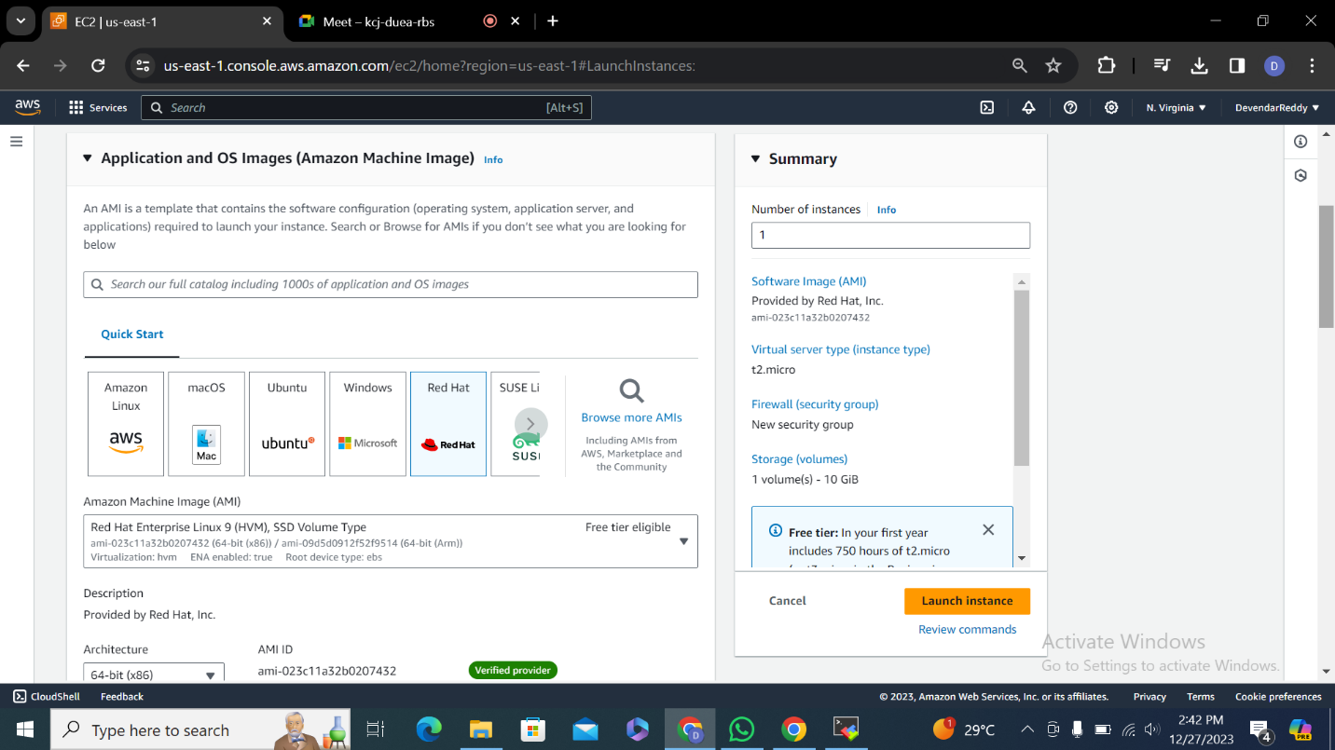

Step-3 enter key pair name and select .pem file and create key pair

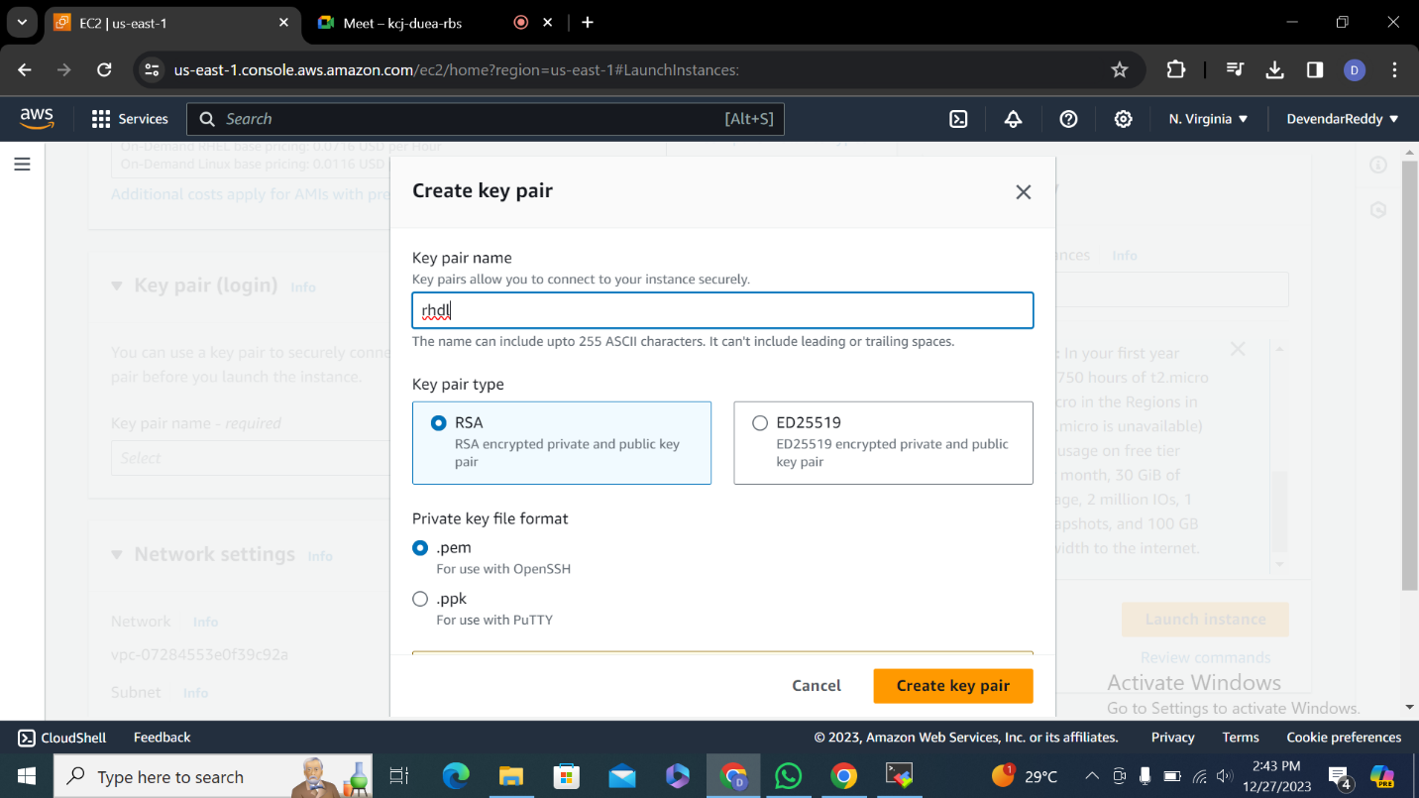

Step-4

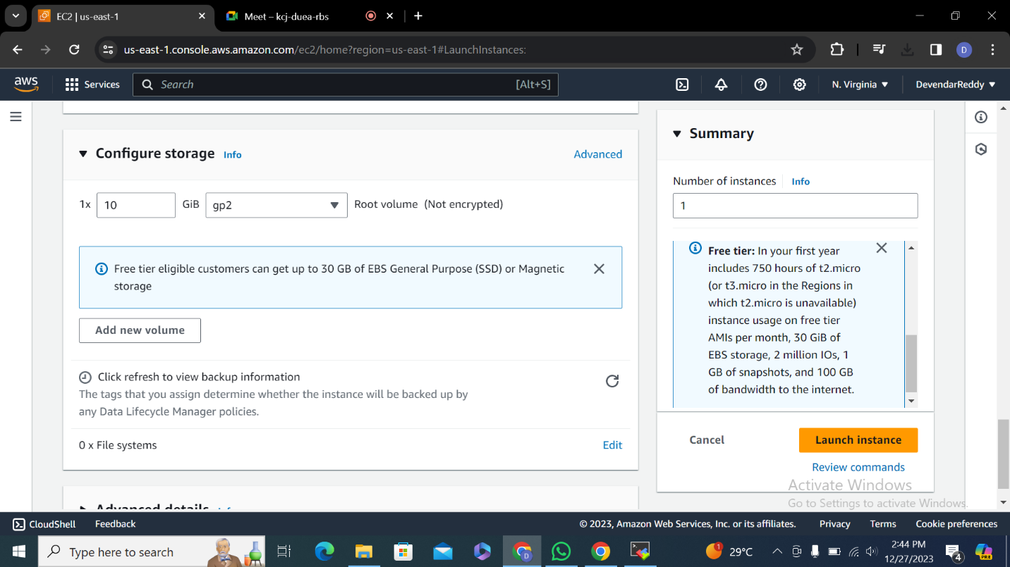

Step-5

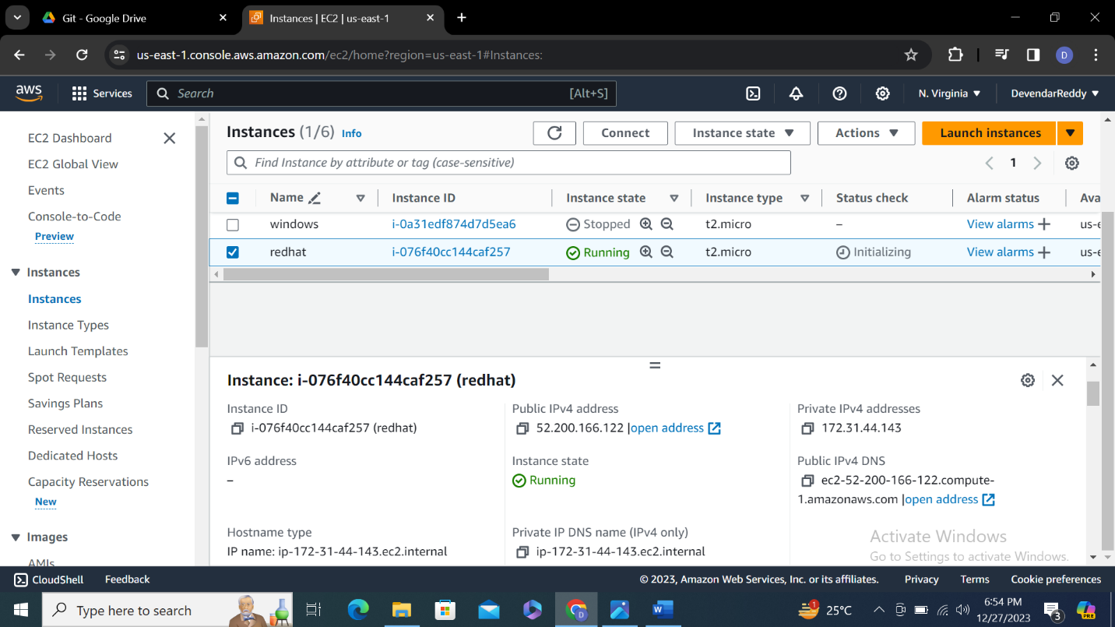

Step-6 open moba xterm and and enter public ip address user name upload key pair

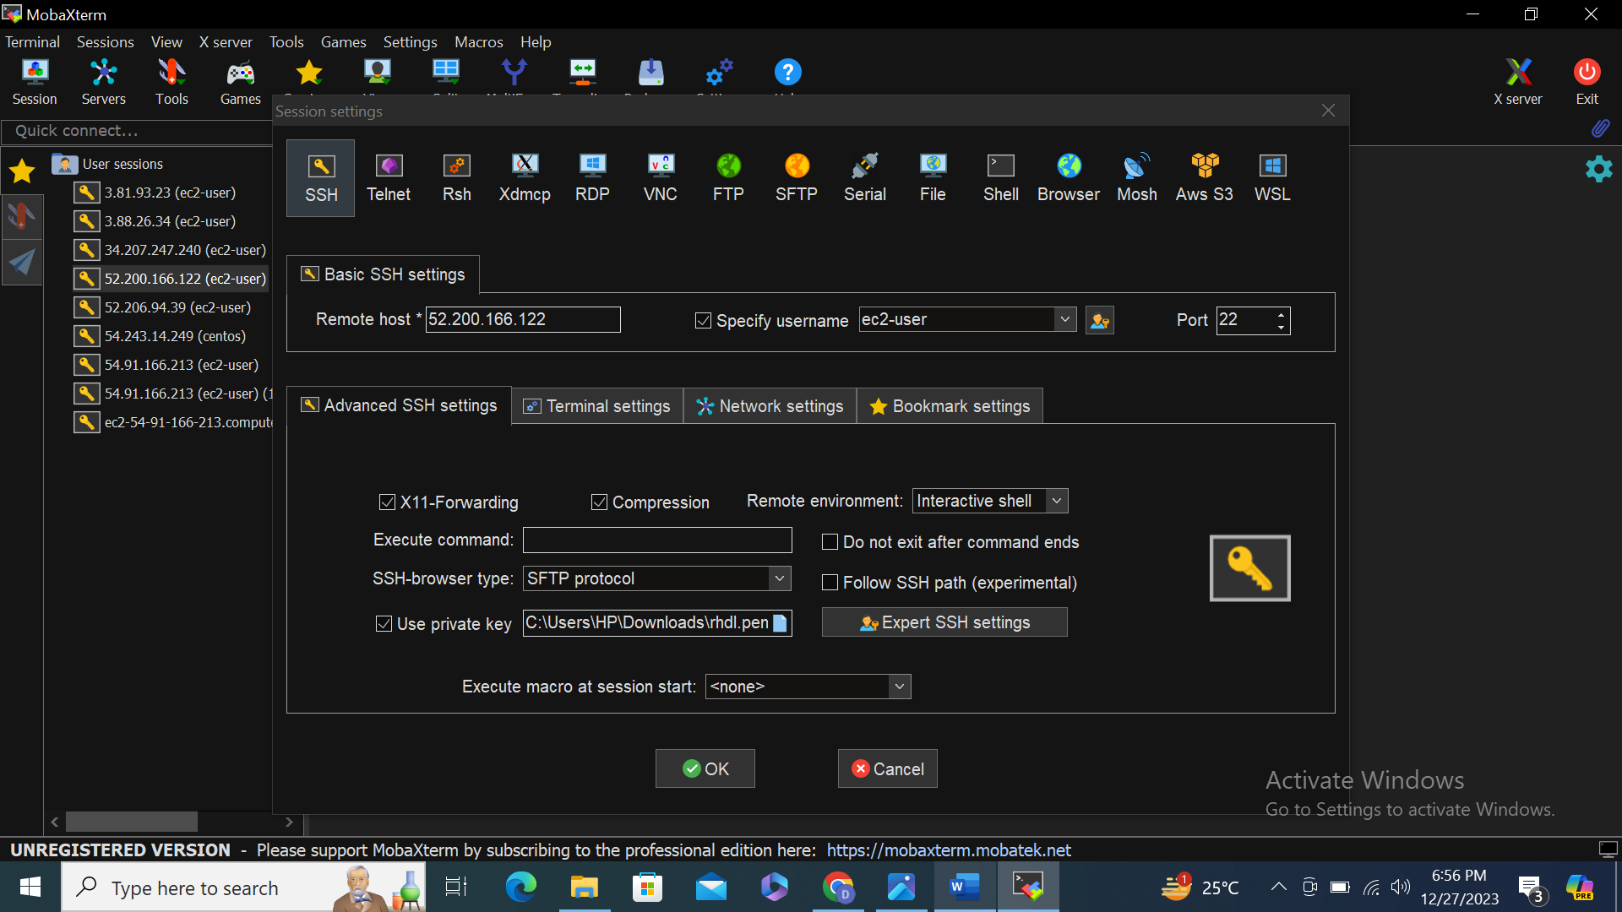

Step-7

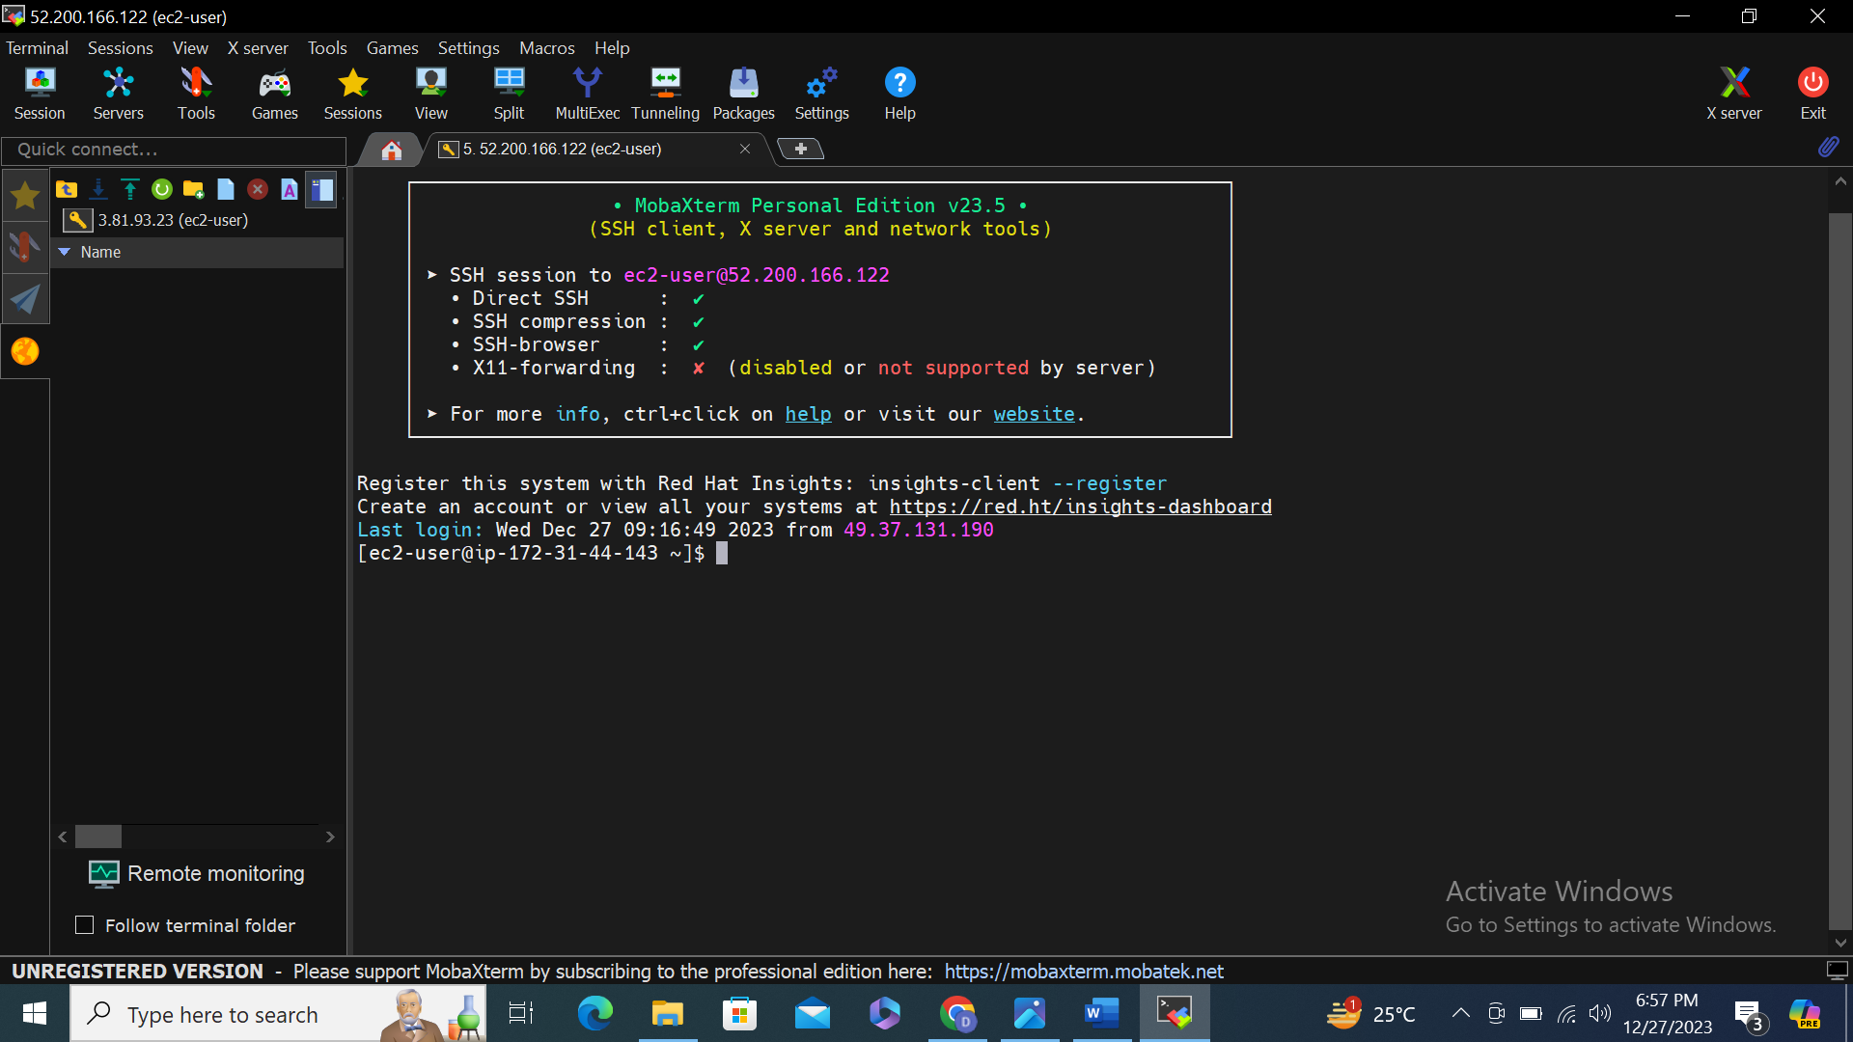

Step-8 check public and private ip address both are same or not in aws dashboard 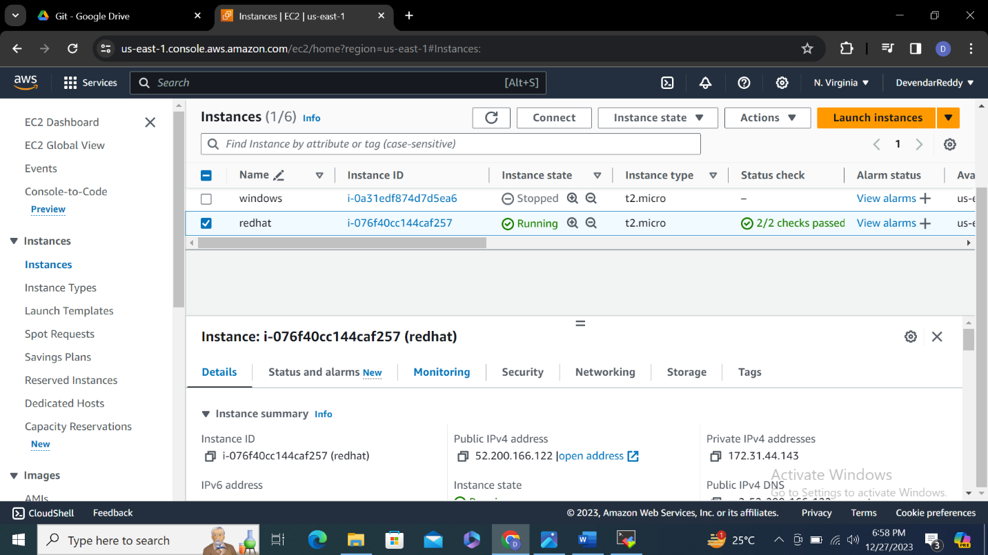

**2.** **Ubuntu.**

**Step-1**

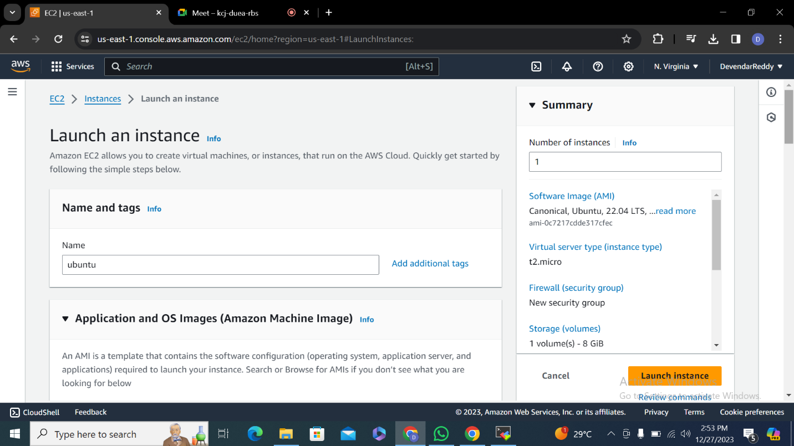

**Step-2 select ubuntu and and select key pair as .pem file**

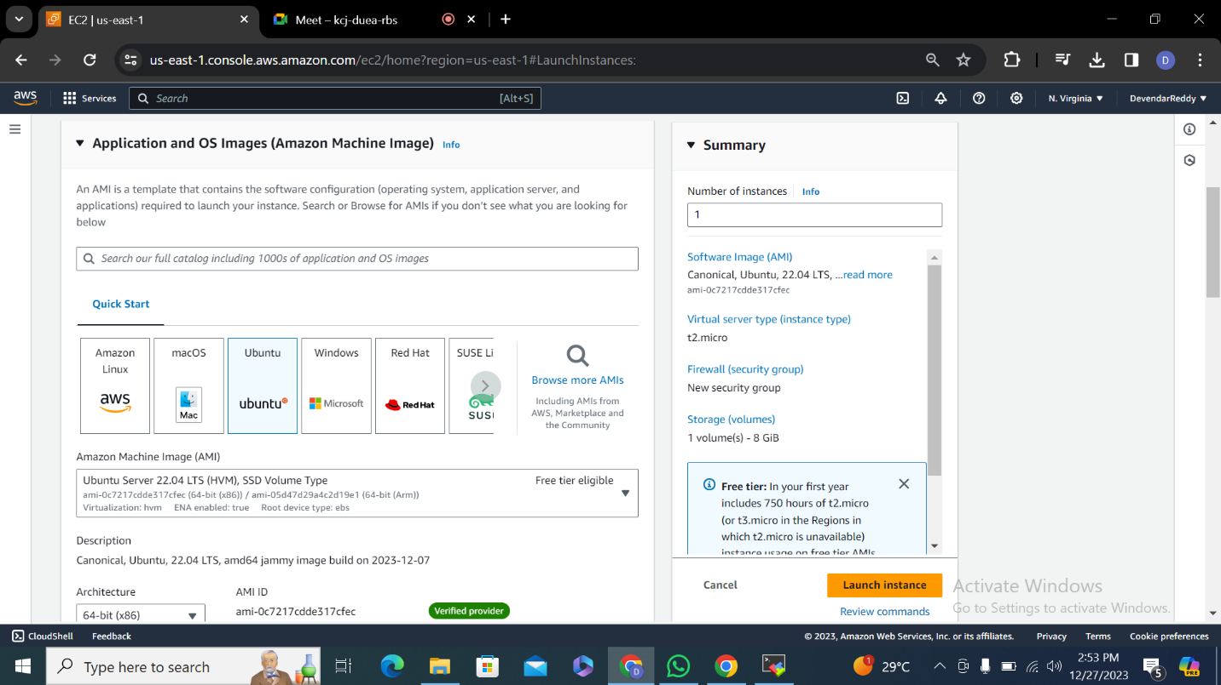

**Step-3 click launch instance**

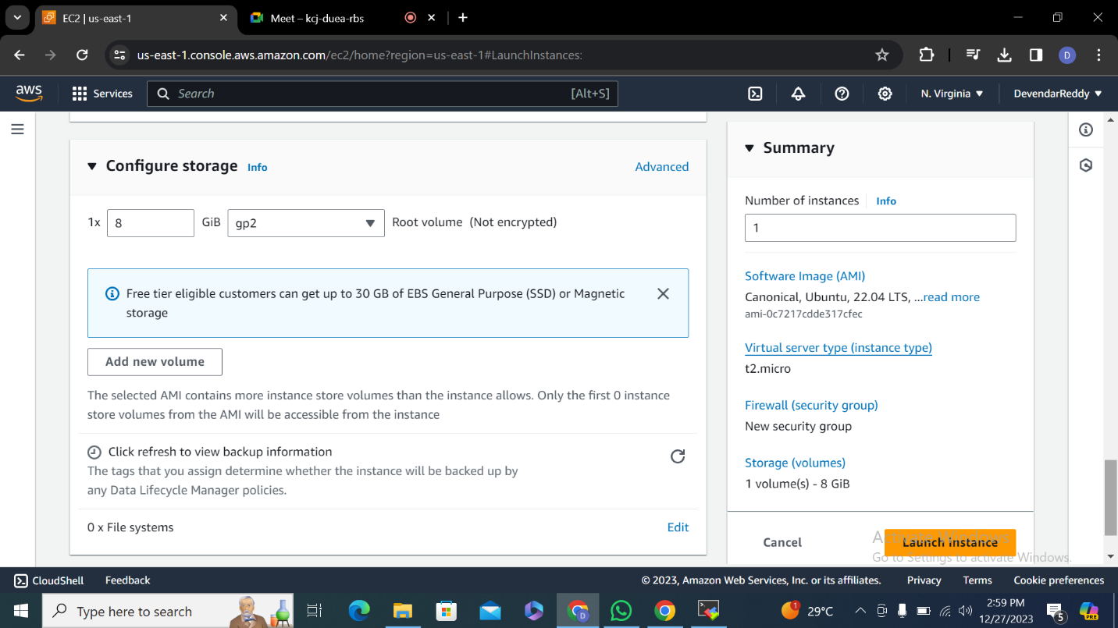

**Step-4**

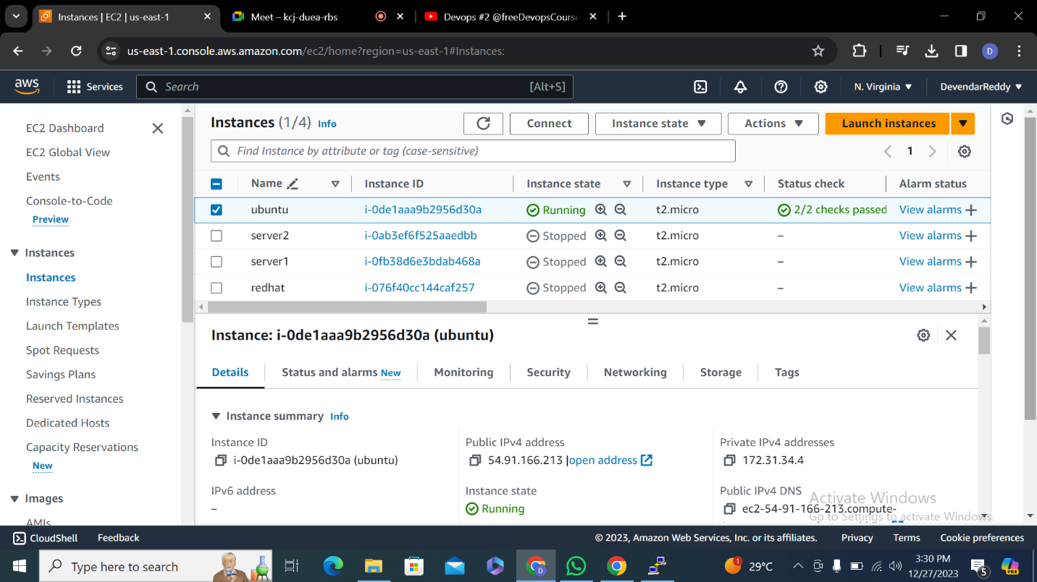

**Step-5 putty gen is used to convert .pem to .ppk file**

**Open putty gen** 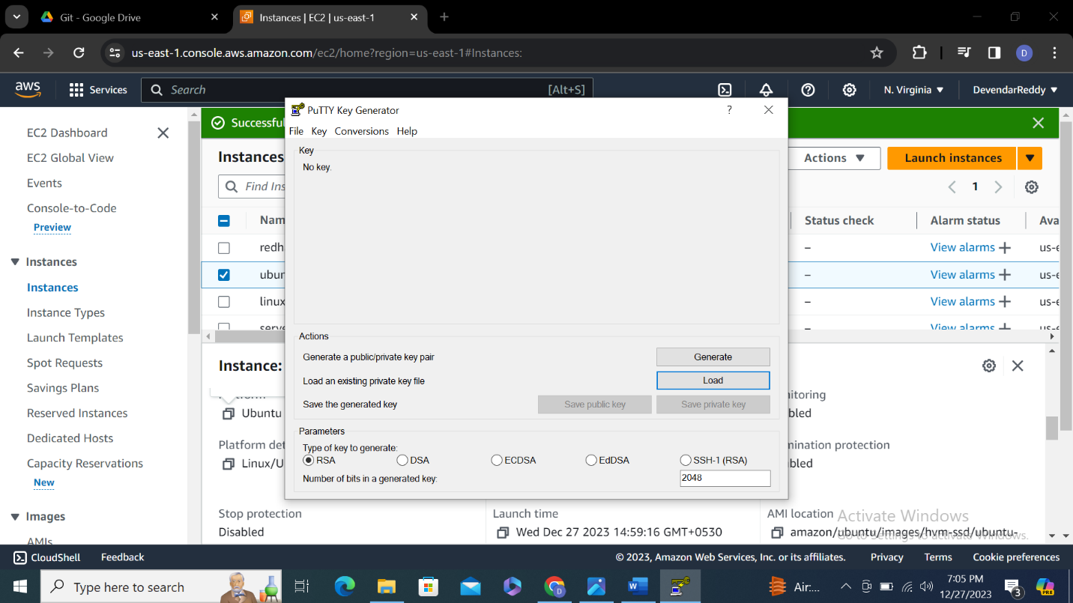

**Step-6 click open select .pem file and click save private key .pem changes to .ppk.**

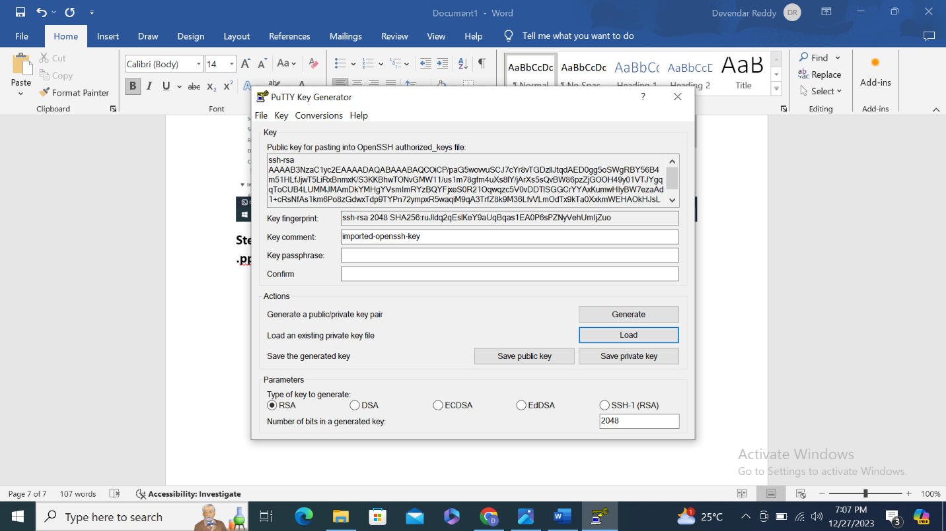

**Step-7 open putty tool enter public ip address**

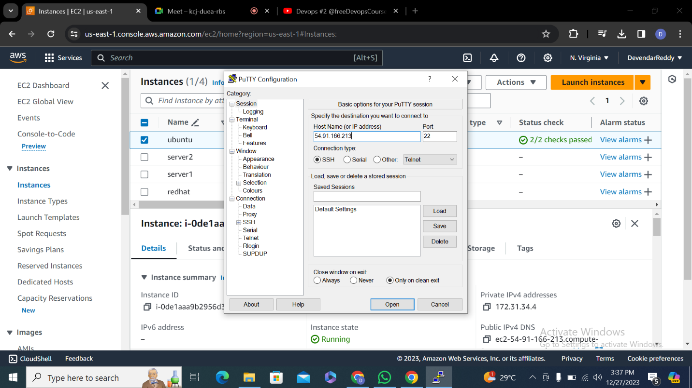

**Step-8 go to SSH –Auth –credentials upload .ppk file click open**

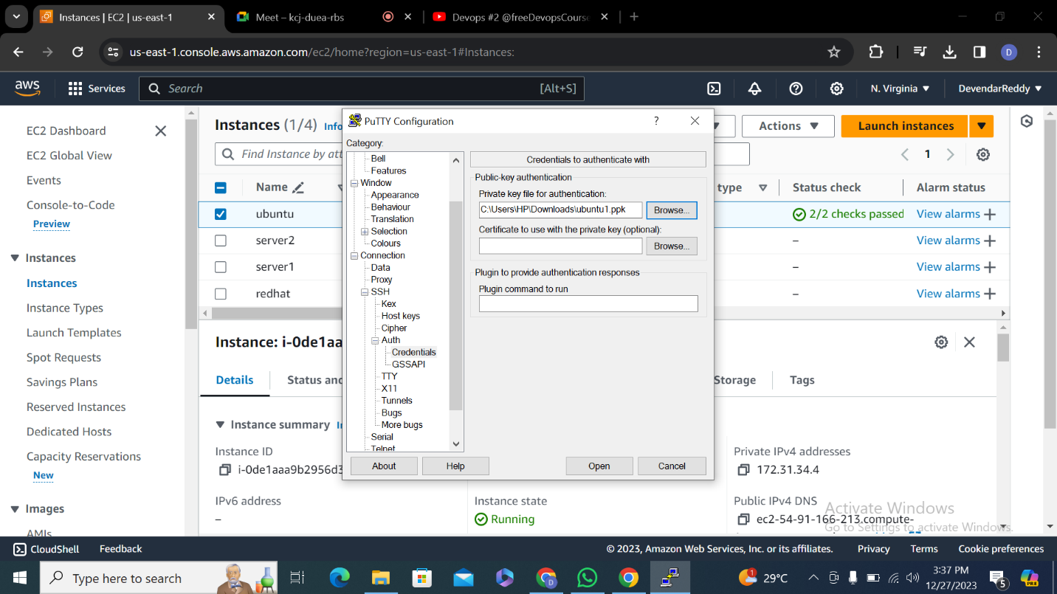

**Step-9 putty command will open it will ask login as enter ubuntu**

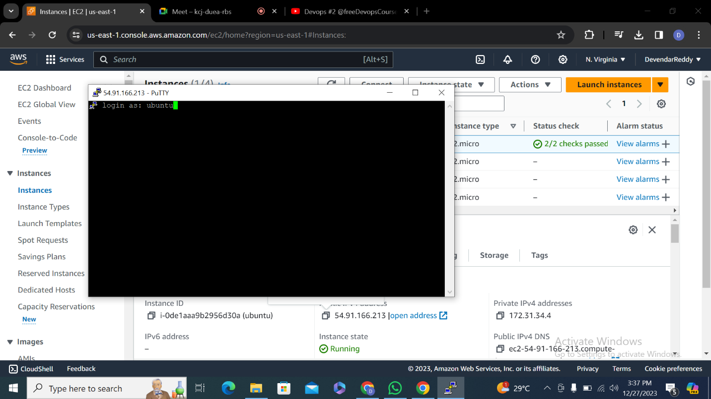

**Step-10 check public ip and private ip address both are same**

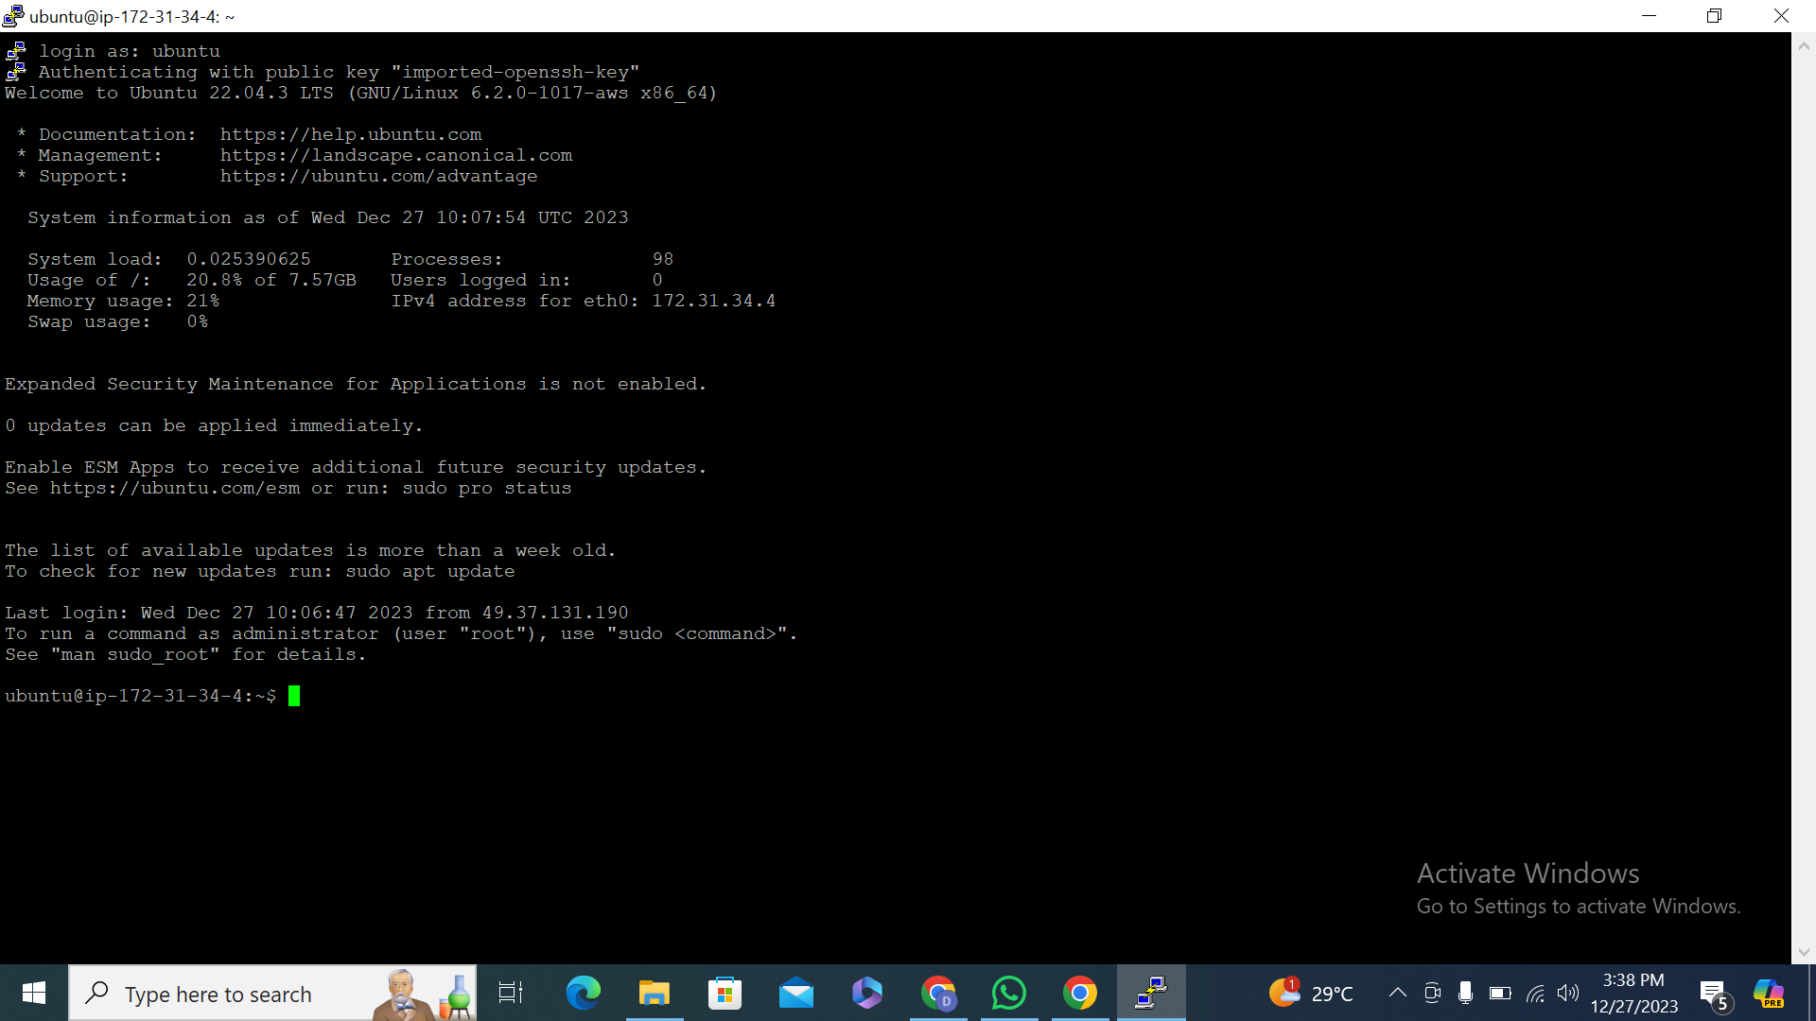

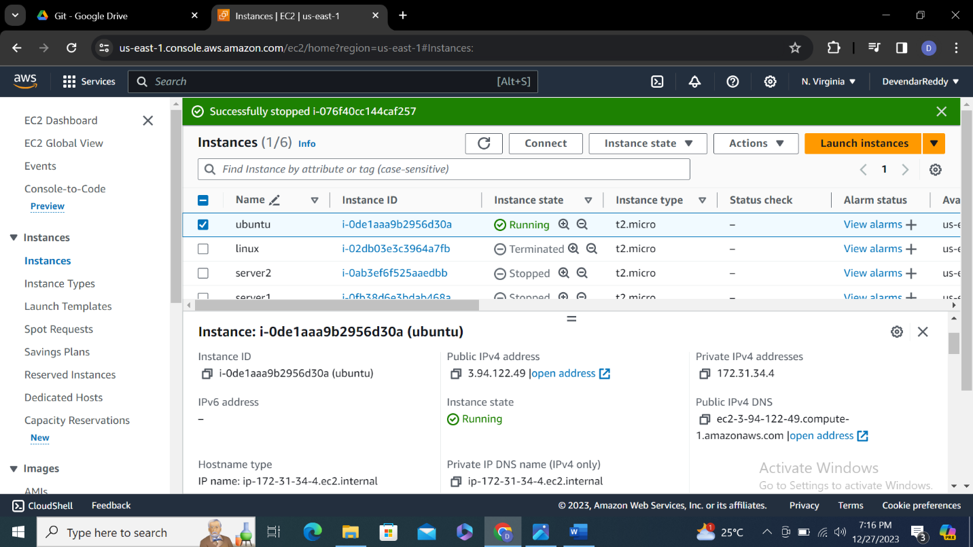

**Microsoft Windows (3rd instance)**

**Step-1**

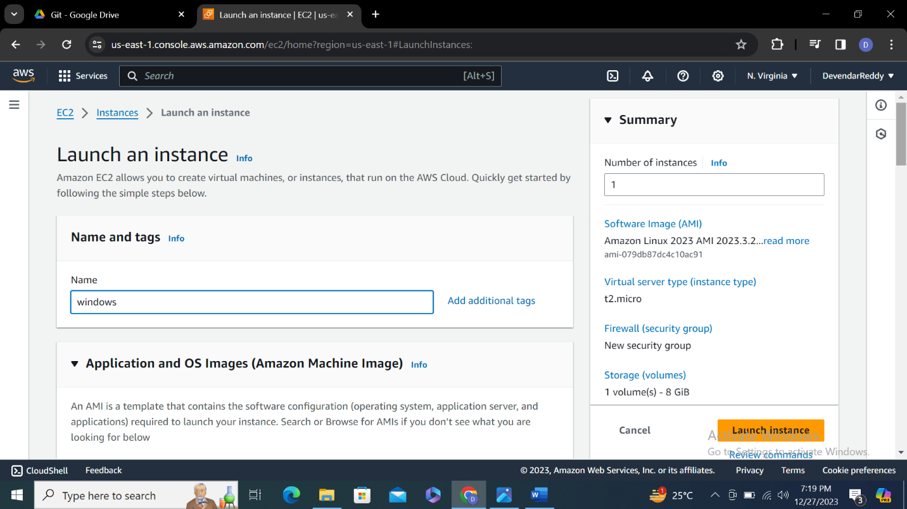

**Step-2**

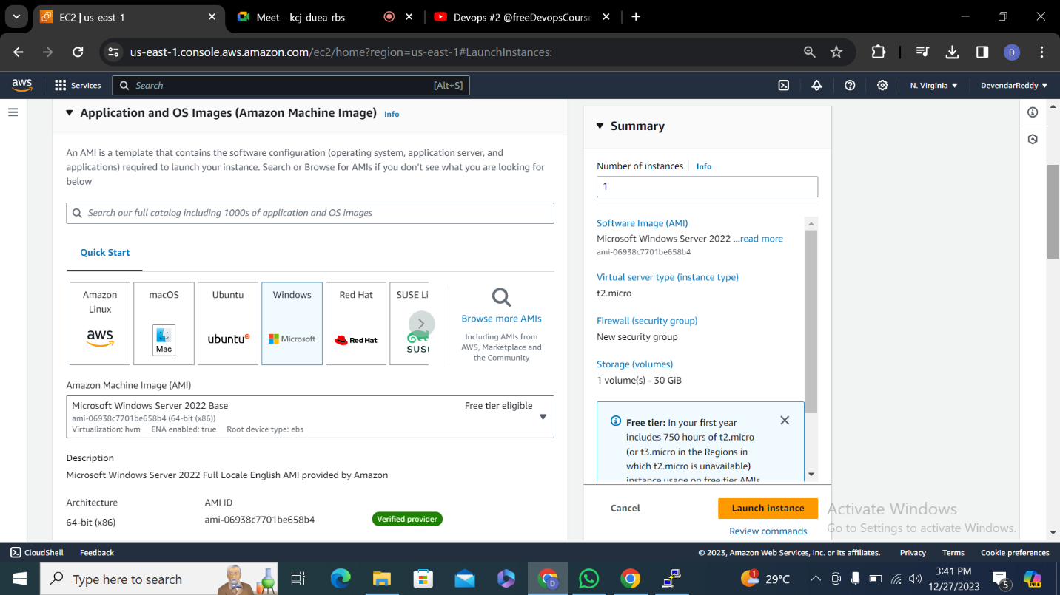

**Step-3 instance t2 micro and key pair**

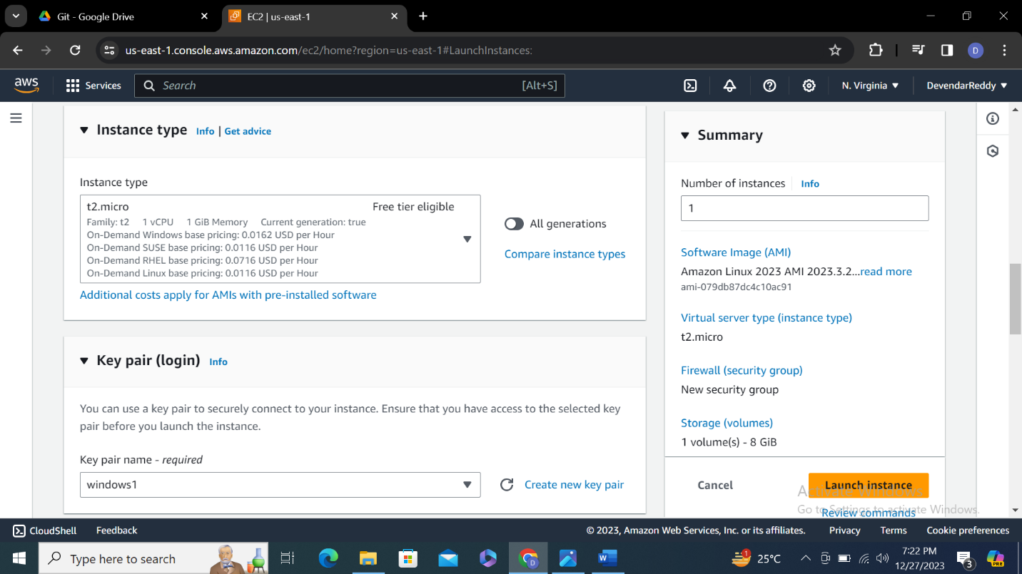

**Step-4 networking setting should be default** 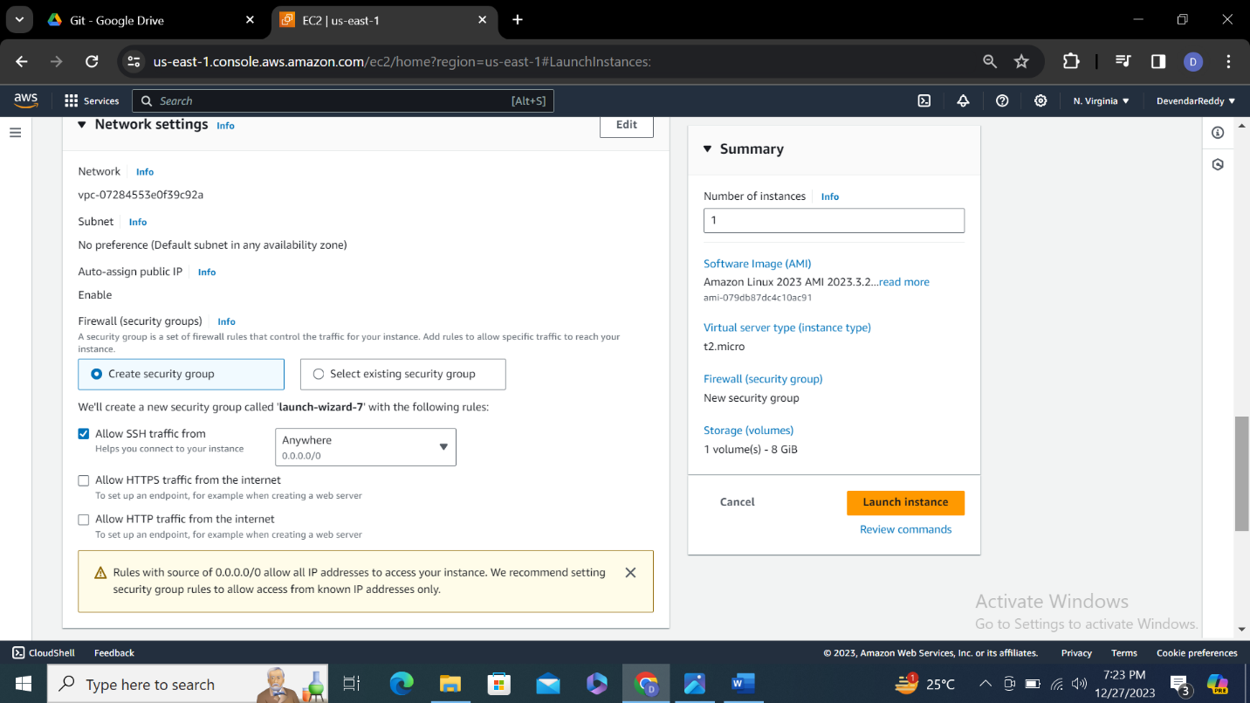

**Step-5 cofigure setting default and click launch instance**

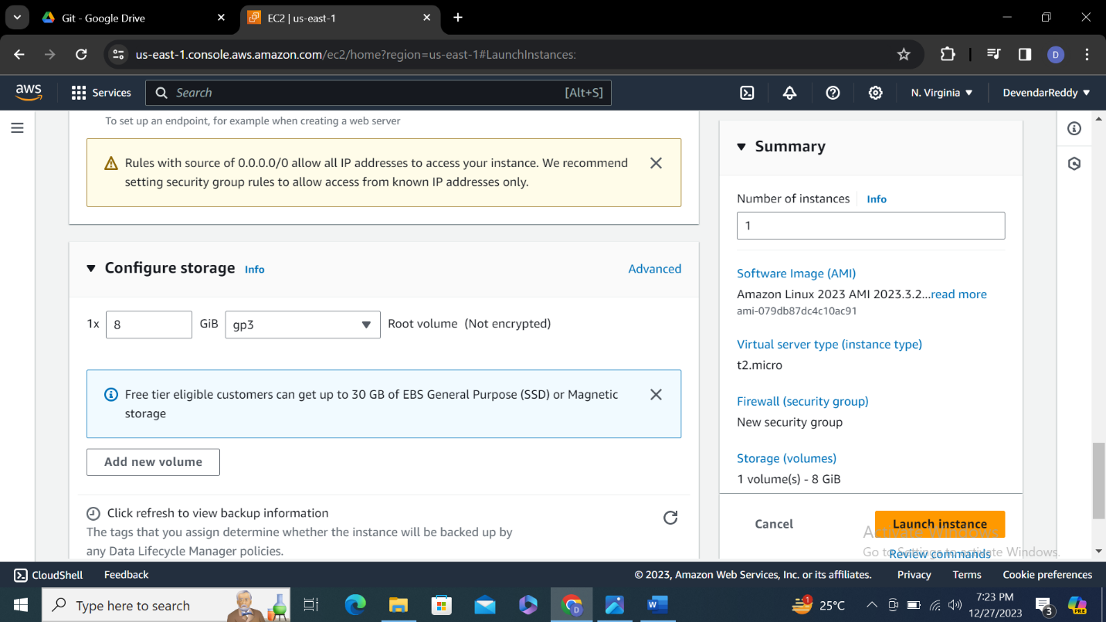

**Step-6 open remote desktop connection in laptop** 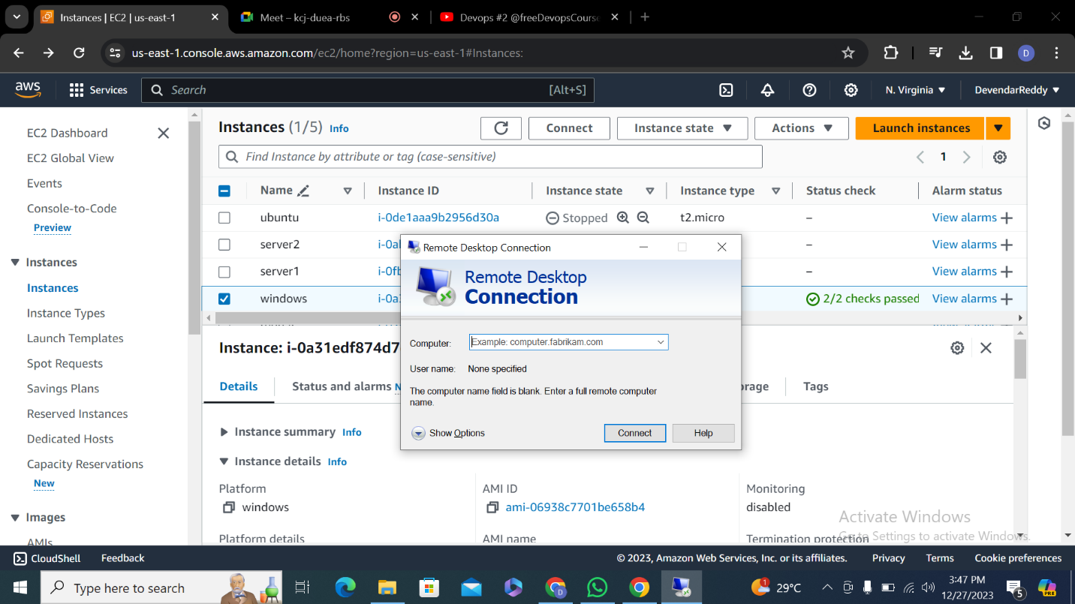

**Step-7 enter public ip address**

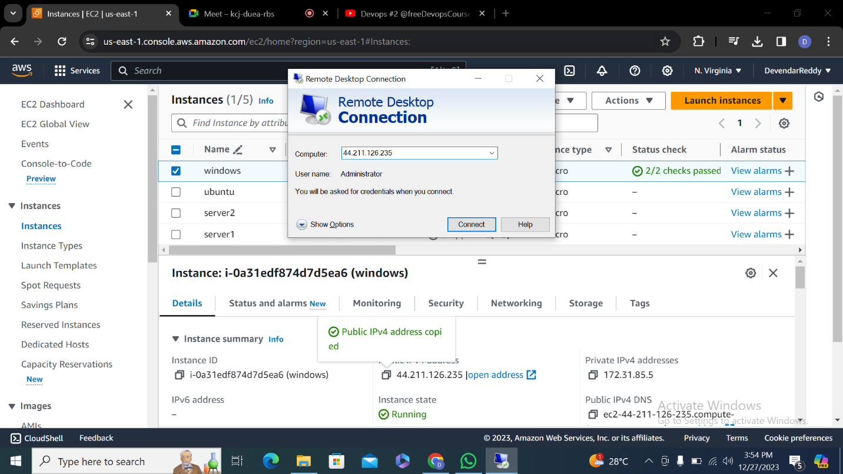

**Step-8 go to dash board on top there is a connect click on it.**

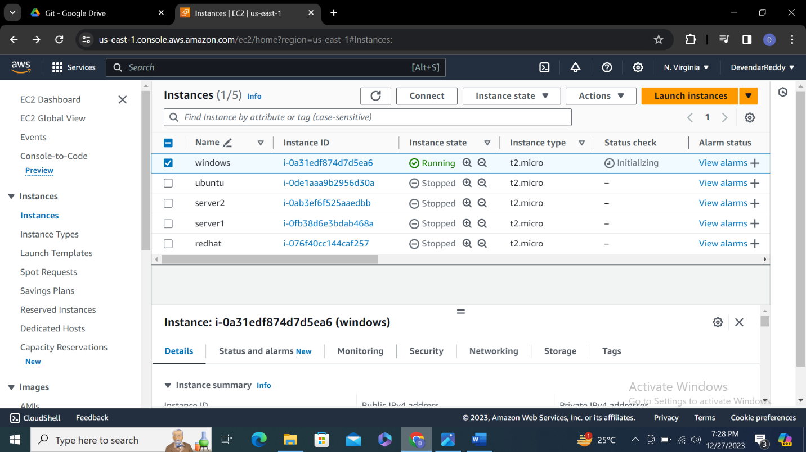

**Step-9 click on RDP client and click generate password** 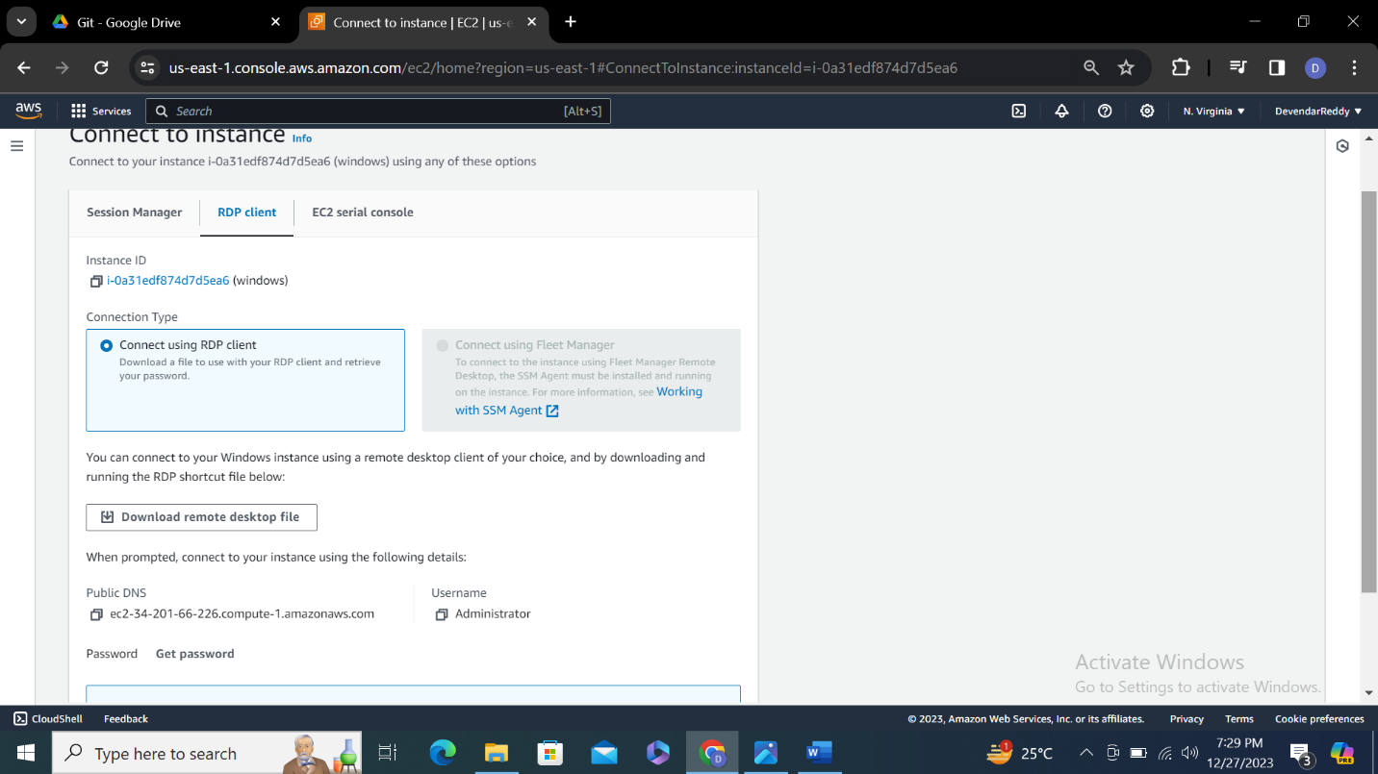

**Step-10 upload .pem file and click on decrypt password**

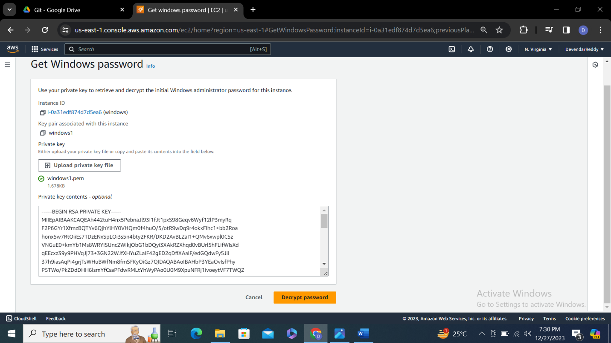

**Step-11 copy password**

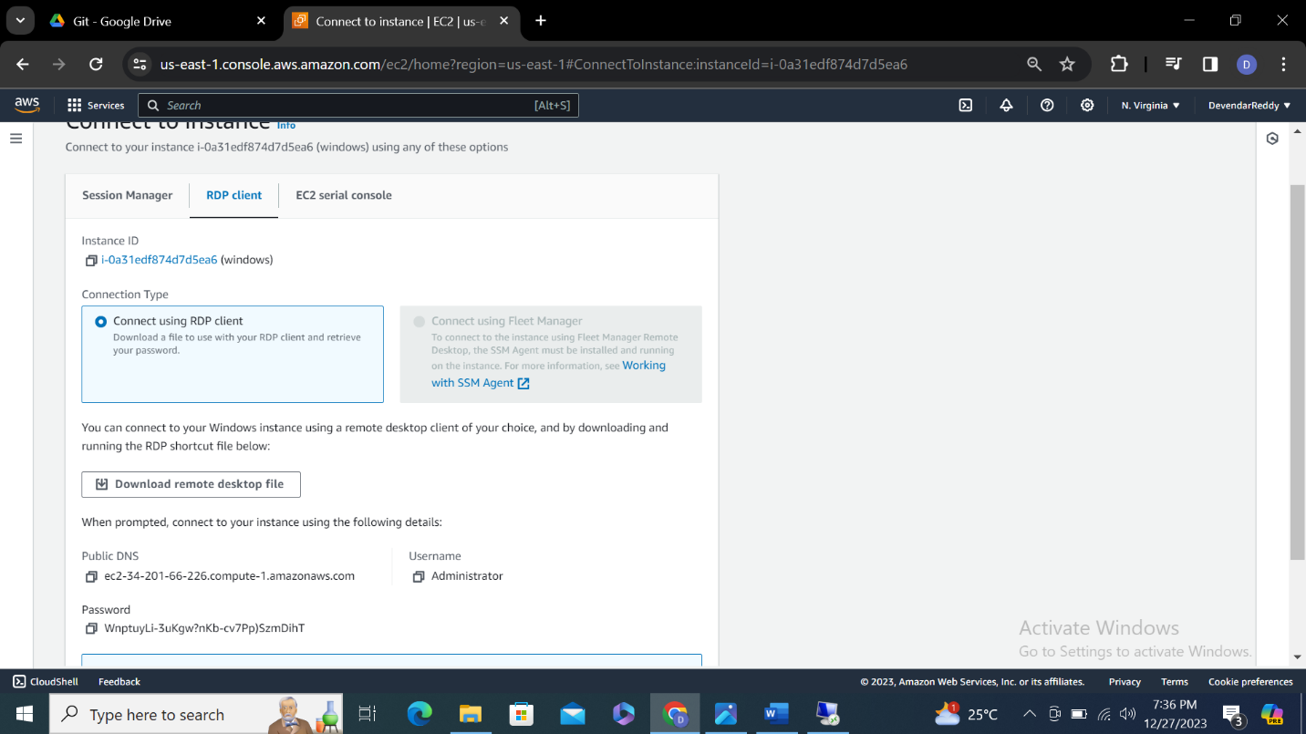

**Step-12 enter user name name password click ok**

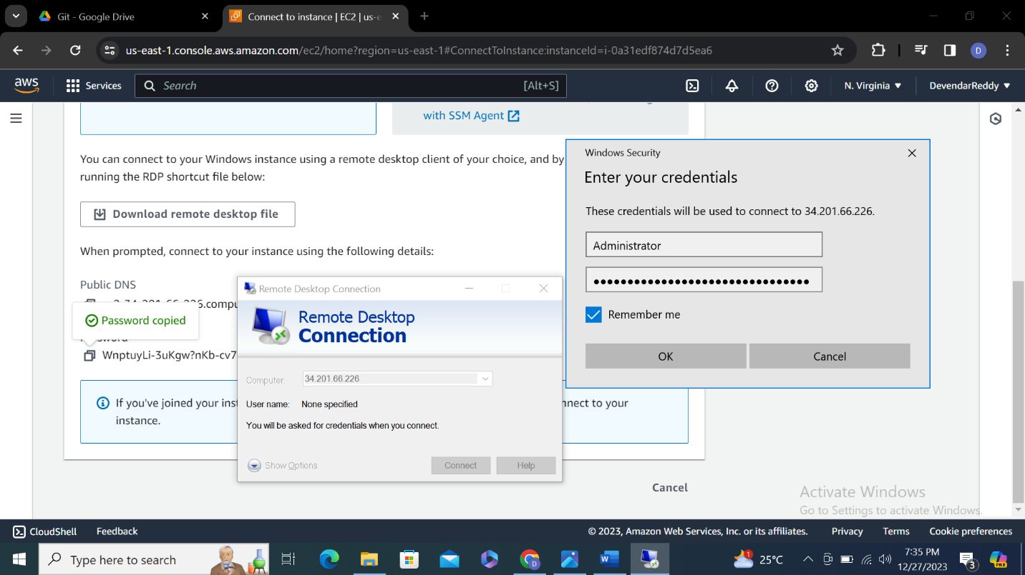

**Step-13 click on yes**

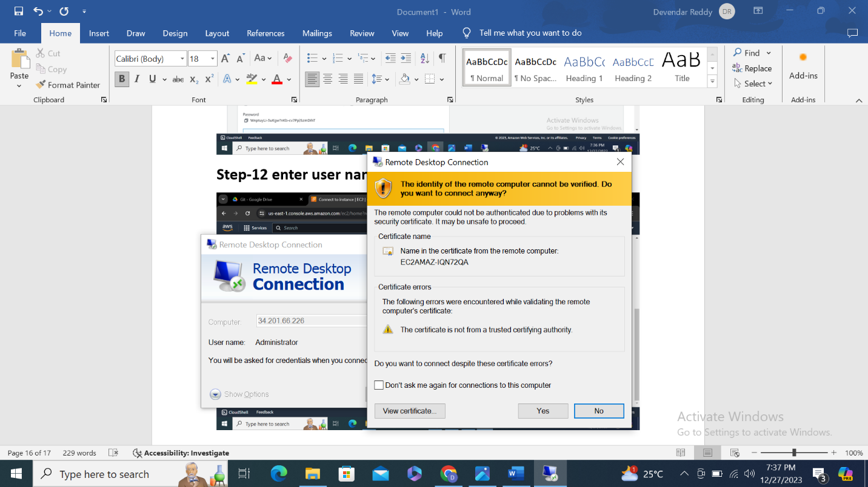

**Step-14**

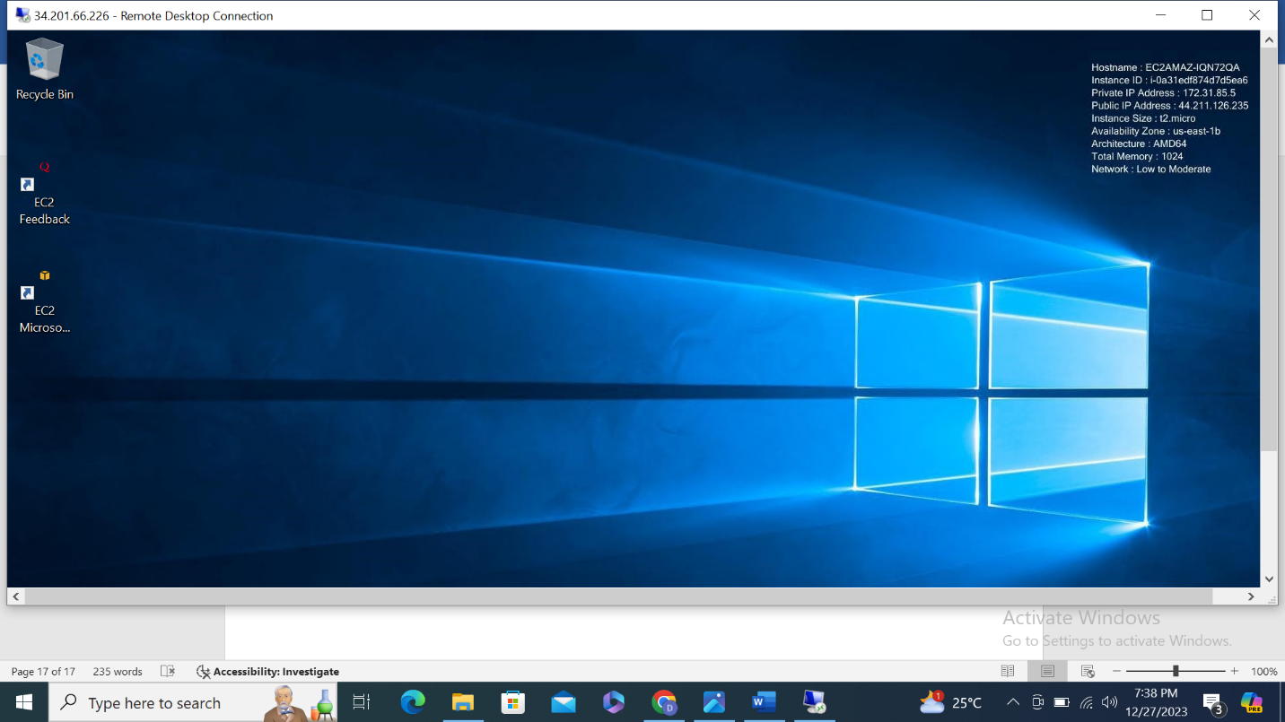

**CentOS (4th instance)**

**Step-1**

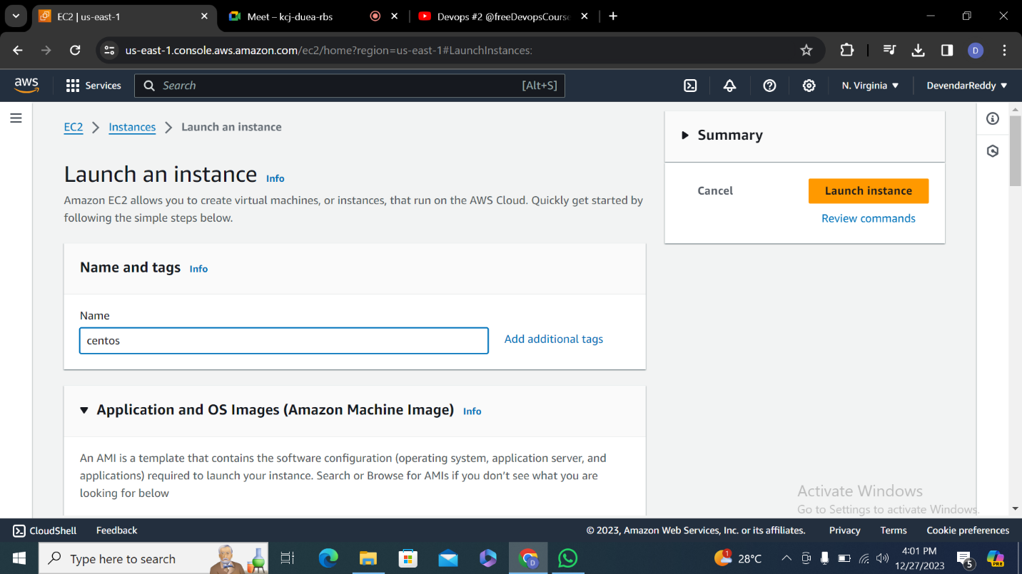

**Step-2**

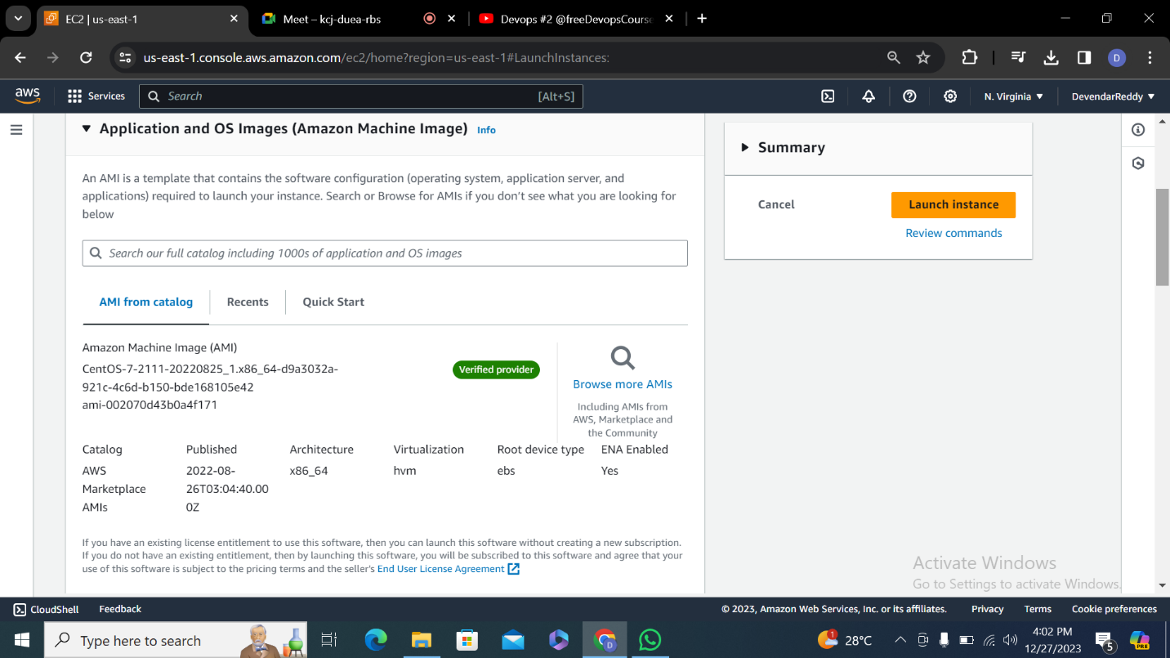

**Step-3**

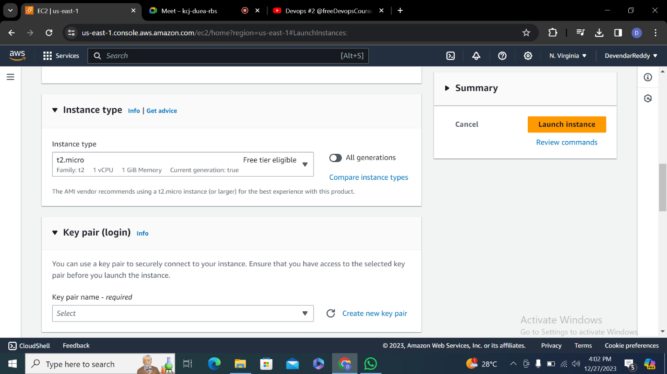

**Step-4**

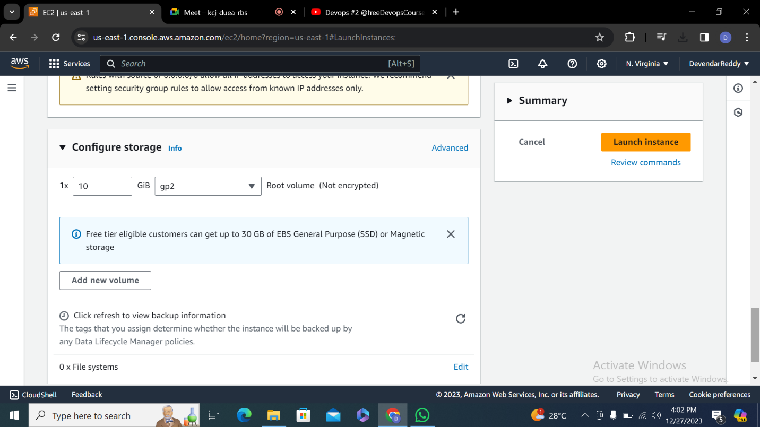

**Step-5**

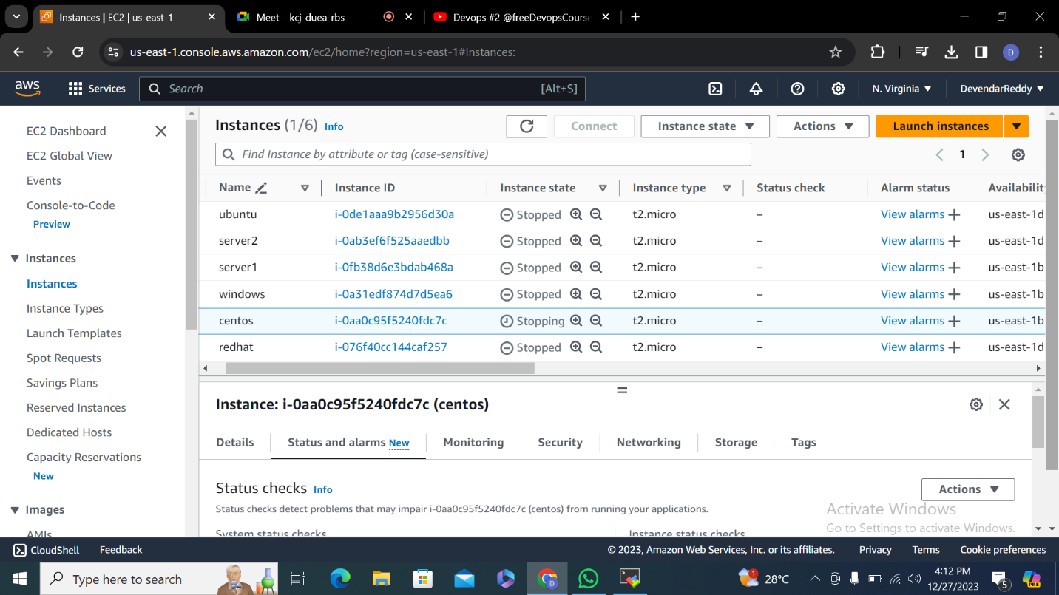

**Step-6**

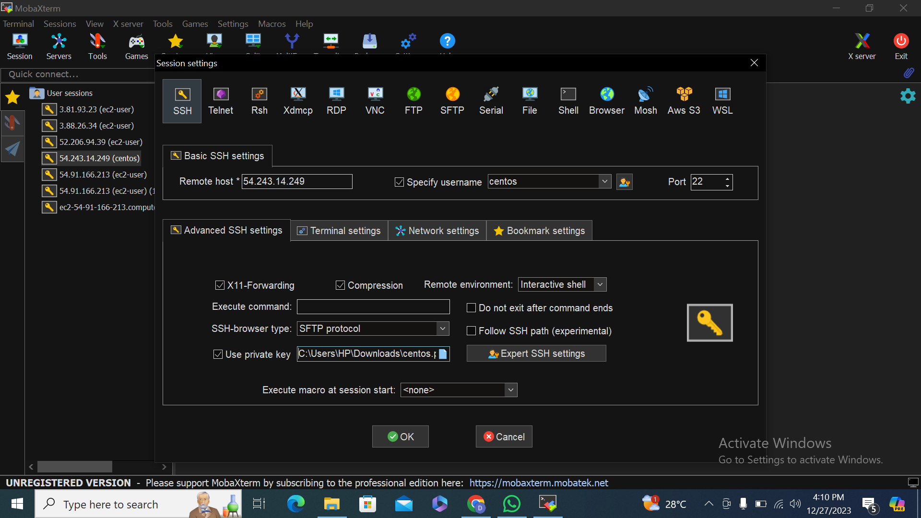

**Step-7**

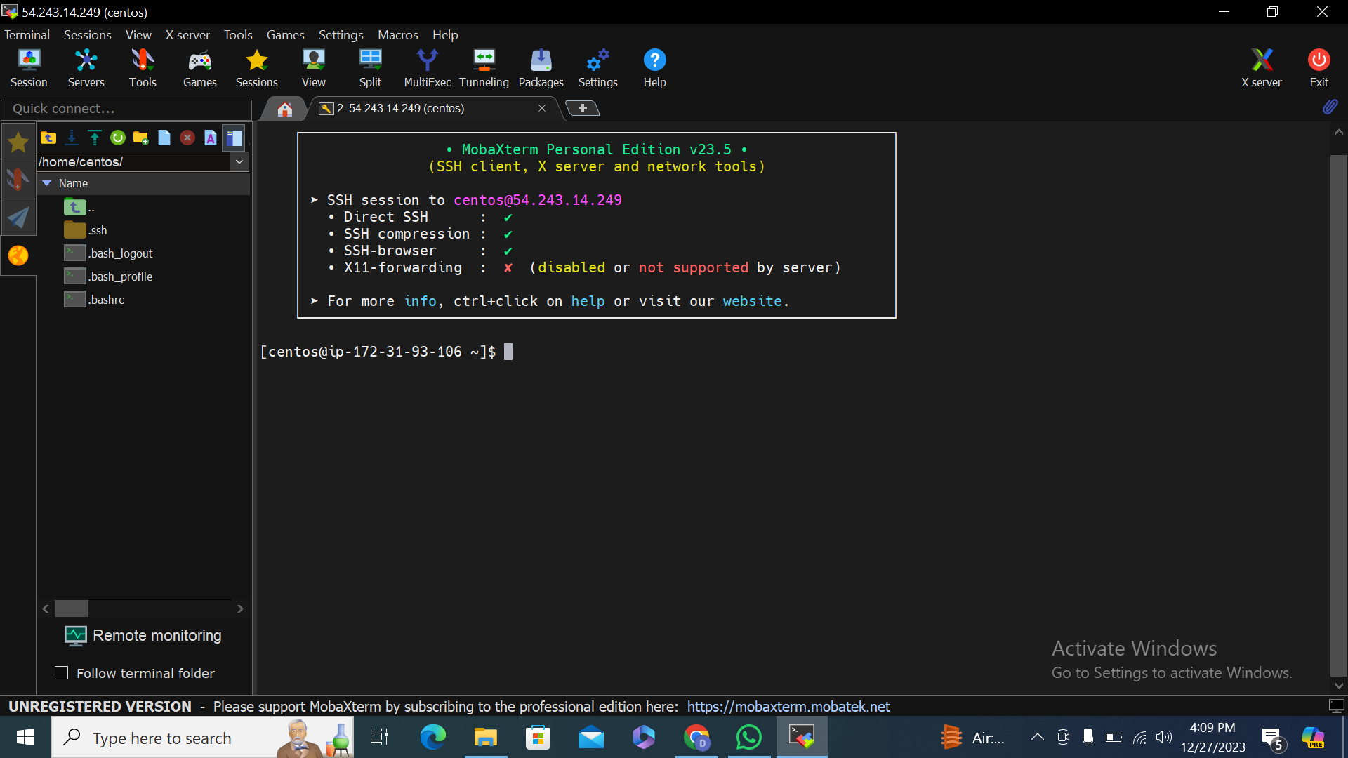

**Step-8**